**Input (File I/O):**

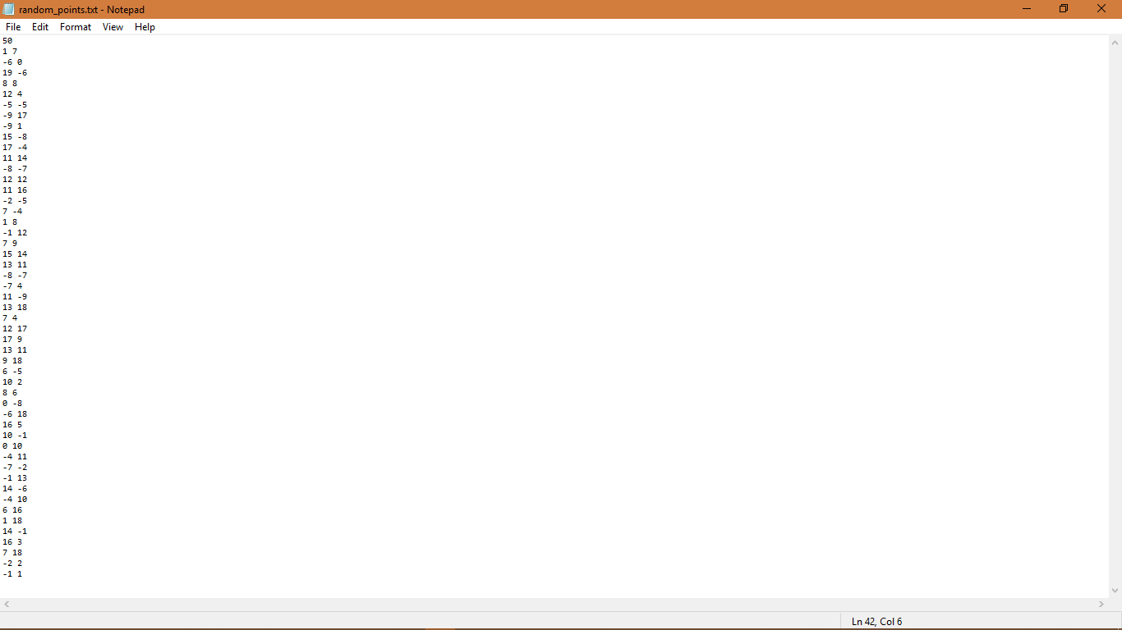

**Output (Graham Scan Algorithm):**

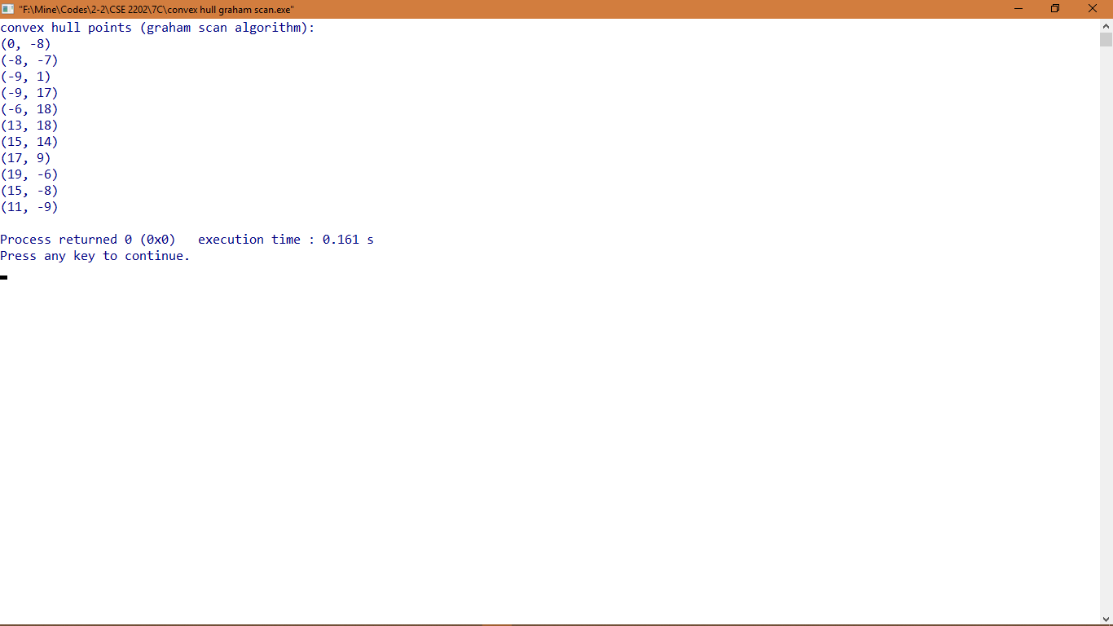

**Output (Divide & Conquer Algorithm):**

